**Screenshots and link of the Dataset**

* **First Graph**

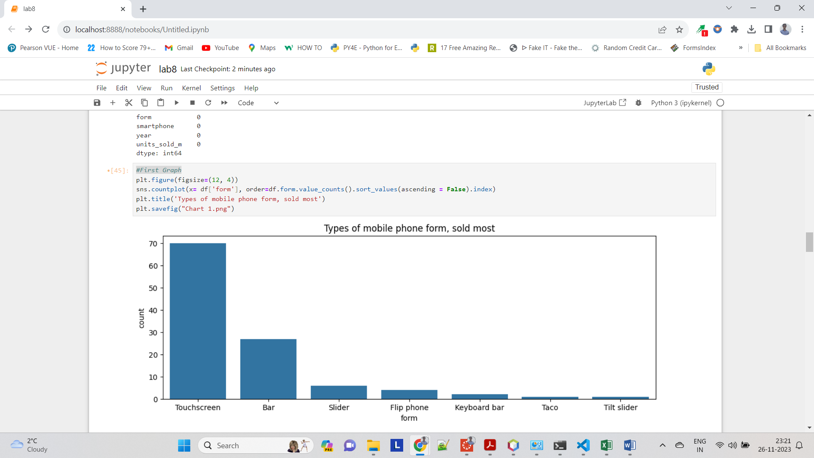

* **Second Graph**

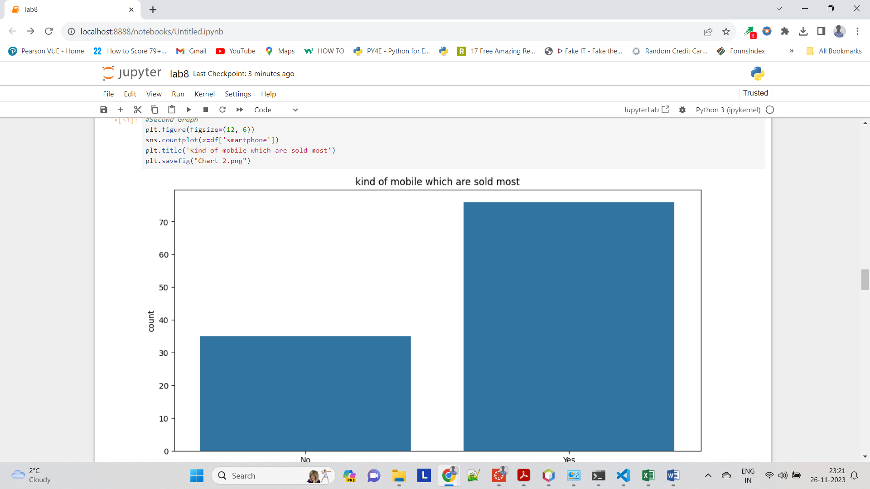

* **Third Graph**

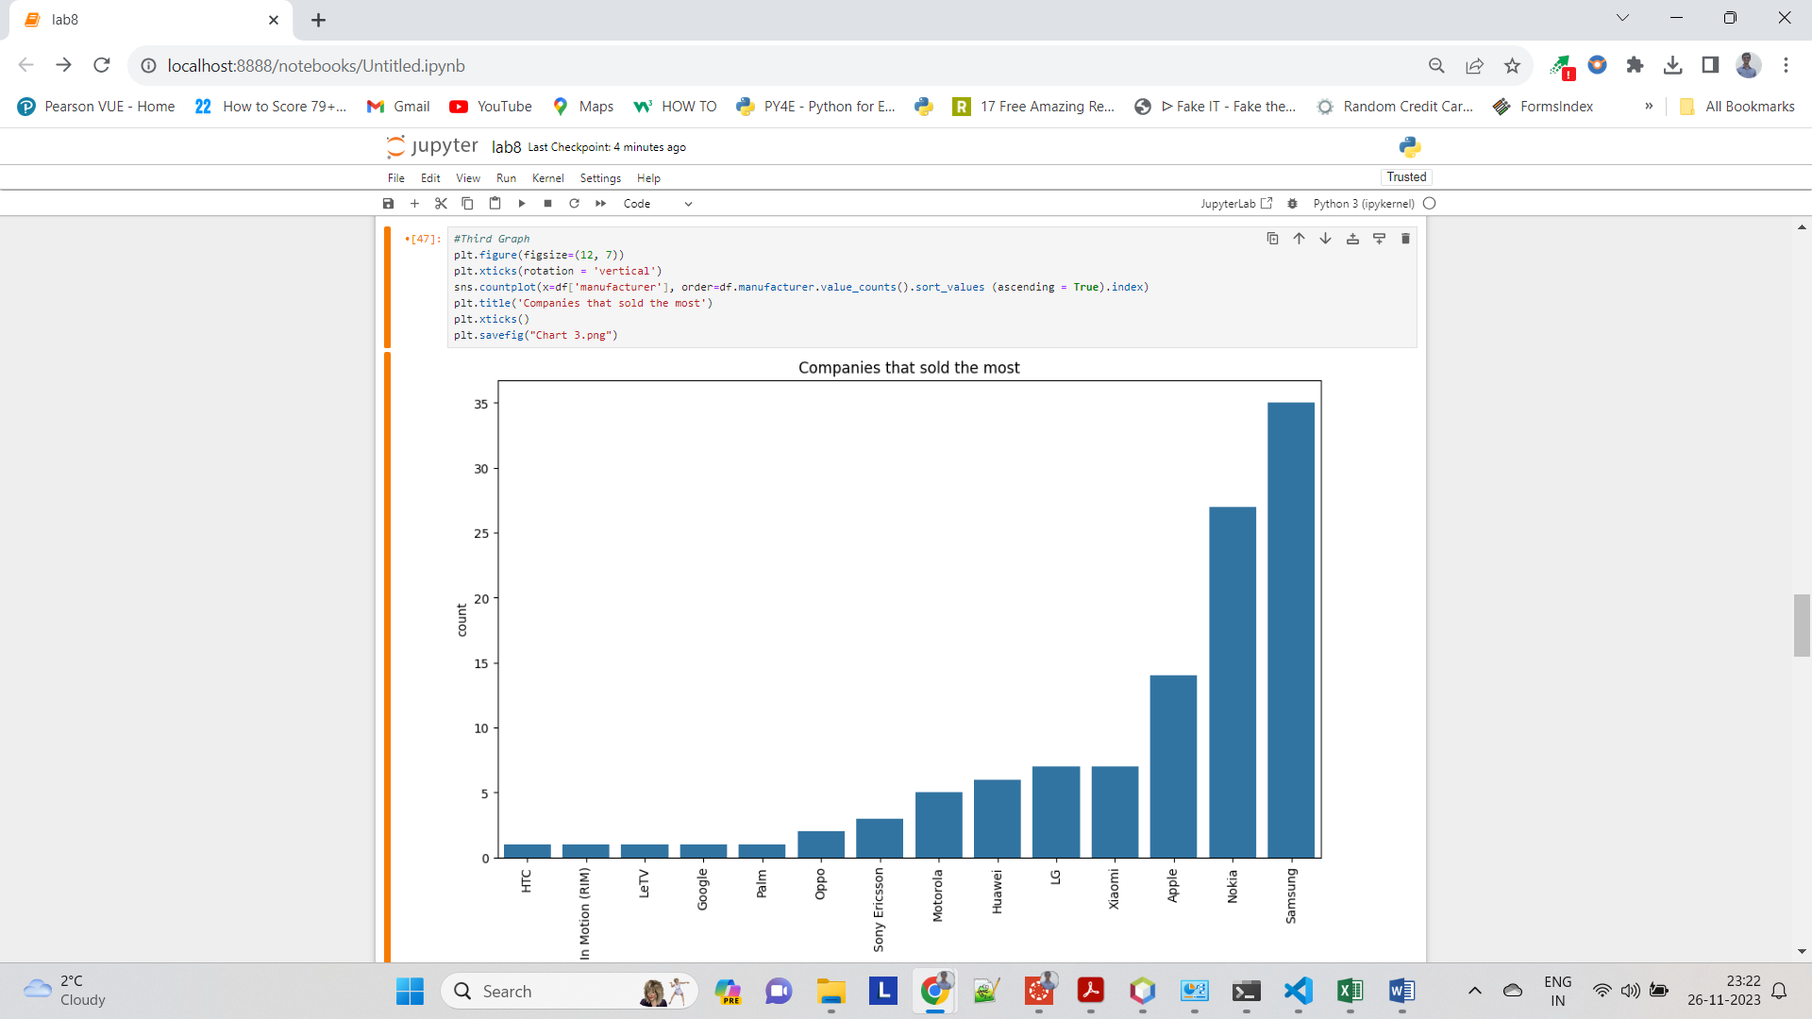

* **Fourth Graph**

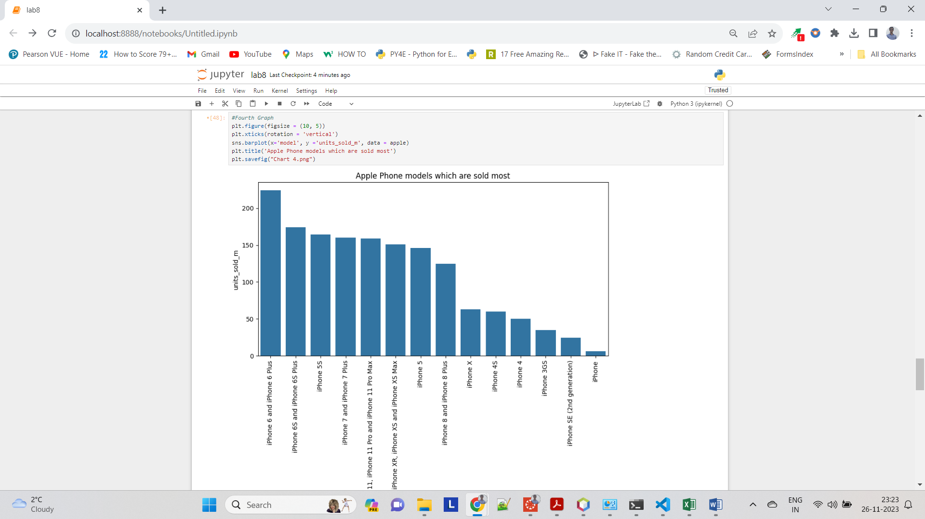

* **Fifth Graph**

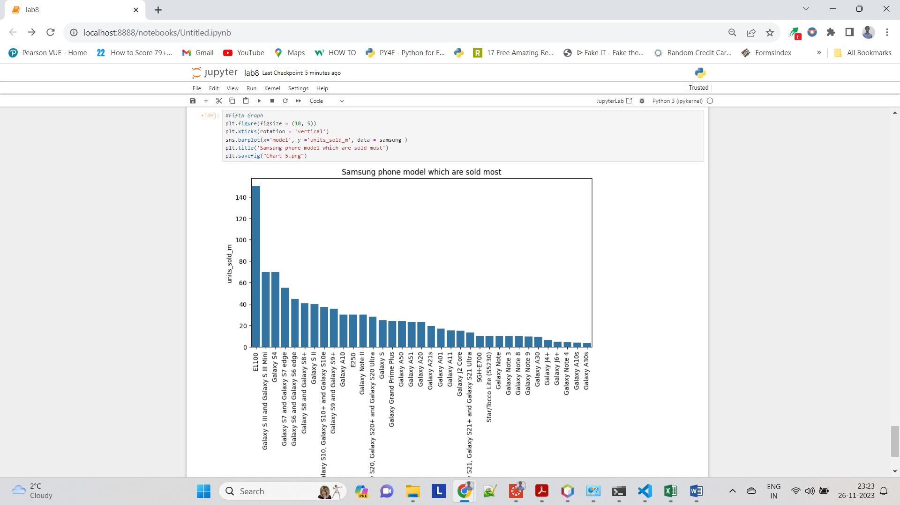

* **Link of the Dataset (From Kaggle)**

<https://www.kaggle.com/datasets/muhammedtausif/best-selling-mobile-phones/download?datasetVersionNumber=4>